COMPUTER SYSTEMS

**COMPUTERSYSTEMS**

**ASSIGNMENT REPORT**

**Presented by**

**MYA THANDAR OO**

**11/10/2012**

NCC Education

Greenwich University



**NCC EDUCATION**

**LEVEL 4 DIPLOMAS IN COMPUTING**

**Module : COMPUTER SYSTEMS**

**Candidate Name : MYA THANDAR OO**

**NCC Candidate Number : 00139877**

**Title : COMPUTER SYSTEMS**

**Exam Cycle : December 2012**

**Word Count**  : **3219**

|  |
| --- |
| **Marker’s comments:** |
| **Moderator’s comments:** |
| **Mark:** |
| **Moderated Mark:** |
| **Final Mark:** |

**TABLE OF CONTENTS**

**INTRODUCTION** 7

**ACKNOWLEDGEMENT** 8

**1.1 Installation of Windows** 10

**1.1.1** **Windows Vista** 10

**1.1.2** **Windows Vista Basic PC** 10

**1.1.3** **Key Stages of Installation** 10

**1.2** **Required Device Drivers Installation** 20

**1.2.1** **Location of Device Driver Software** 22

**1.3** **Installation of Anti-Virus Software** 24

**1.3.1**  **Microsoft Security Essential** 24

**1.4 Installation of Microsoft Office software** 28

**1.5** **Installation of Microsoft Free Tune Up Utility** 30

**1.5.1** **Key Stages of Installation** 31

**2.1 Installation of Red Hat Linux** 35

**2.2** **System Testing** 47

**2.2.1** **Unsolved Problems** 47

**3.1** **Faulty PC** 49

**3.1.1** **Power Supply Problem & Fault Remedy** 49

**3.1.2** **System Boards Problems & Fault Remedy** 49

**3.1.3** **RAM Problems & Fault Remedy** 49

**3.1.4** **Microprocessors Problems & Fault Remedy** 50

**3.1.5** **ROM Problems & Fault Remedy** 50

**3.1.6** **Keyboard Problems & Fault Remedy** 50

**3.1.7**  **Mouse Problems & Fault Remedy** 50

**3.1.8** **Video Display Problems & Fault Remedy** 50

**3.1.9 Hard – Disk Drive Problems & Fault Remedy** 50

**3.1.10** **Network Cards Problems & Fault Remedy** 51

# 

# **LIST OF FIGURES**

Figure 1 Windows is loading Files 10

Figure 2 Setting Language 11

Figure 3 Install Fresh Version of Windows Vista 11

Figure 4 Type the product key for activation 12

Figure 5 Select the Edition of Windows that purchased 12

Figure 6 Read the license terms 13

Figure 7 Select Installation Types 13

Figure 8 Primary Partition on the Hard disk 14

Figure 9 Disk Unallocated Space 14

Figure 10 Installing Windows 15

Figure 11 Installing Updates 15

Figure 12 Complete Installation 16

Figure 13 Set up Windows 16

Figure 14 Windows Protection Setting 17

Figure 15 Time and Date Settings 17

Figure 16 Finishing Setup 18

Figure 17 Windows check the Computer performance 18

Figure 18 User Account and its Password 19

Figure 19 Windows Vista Desktop Background 19

Figure 20 Preparing to install Driver Pack Solution 20

Figure 21 Driver Installation Progress 20

Figure 22 Completing Device Driver Installation and restarting the System 21

Figure 23 Configuring the Device Driver Updates 21

Figure 24 Device Manager Program 22

Figure 25 Update Driver Software 22

Figure 26 Search automatically for updated driver software 23

Figure 27 Browse for Driver Software on the Computer 23

Figure 28 Microsoft Security Essential Installation Wizard 25

Figure 29 MS Security Essentials Software License Terms 25

Figure 30 Join the Customer Experience Improvement Program 26

Figure 31 Optimize Security Essentials 26

Figure 32 Ready to install the Program Installation Wizard 27

Figure 33 Complete Installation Wizard 27

Figure 34 Protected PC 28

Figure 35 License Agreement Terms and Accept to continue installing 28

Figure 36 Select the Installation Types 29

Figure 37 Installing Microsoft Office 2010 in progress 29

Figure 38 Complete installation and ready to use 30

Figure 39 Tune up Utility Installation Wizard 31

Figure 40 Accept End User License Agreement 31

Figure 41 Installing Utilities with fast, stable and customized for computer performance 32

Figure 42 Complete Installation of Utilities 32

Figure 43 Running tune up Utilities for Performance Speed up 33

Figure 44 Red Hat Linux Operating System 35

Figure 45 Language Setting 35

Figure 46 Testing Hard disk before installation 36

Figure 47 Red Hat Enterprise Linux 6 36

Figure 48 Select the type of Installation Device 37

Figure 49 Download Software Release Notes 37

Figure 50 Welcome Screen of Red Hat Enterprise Linux 6 Beta Version 38

Figure 51 Locate or Point out the a Place where the user lives 38

Figure 52 Type Root Password and Confirmation 39

Figure 53 Select the type of Installation 39

Figure 54 Partitioning Disk Druid on the All Space of Hard Disk 40

Figure 55 Create a New Partition 40

Figure 56 Install Boot Loader 41

Figure 57 Software Development Workstations 41

Figure 58 Packet Group Details 42

Figure 59 Starting Installation Process 42

Figure 60 Packet Installation completed is still in Progress 43

Figure 61 Finish Basic Installation and reboot the System 43

Figure 62 Initializing and updating the System 44

Figure 63 Forwarding more steps form this welcome Red Hat Linux Window 44

Figure 64 Create a User Account 45

Figure 65 Date and Time Settings 45

Figure 66 Type the predefined User Name 46

Figure 67 Red Hat Linux Desktop Background 46

**Statement and Confirmation of Own Work**

Programmed Qualification Name: **Level 4 Diploma in Computing**

All submitted work must have this form as the cover/ first page. Please include this from as part of a standard format when submitting an assignment.

**Student Declaration**

I have read and understood NCC Education’s regulations on plagiarism.

I can confirm the following details:

**StudentID/ Registration Number : 00139877**

**Name : MYA THANDAR OO**

**Module Name : Computer Systems**

**Module Leader : Daw Lwin Nandar Shwe**

**I confirm that is my own work. I have also noted the grading criteria and pass mark for assignments :**

**Due Date :**

**Student Signature : MYA THANDAR OO**

**Submitted Date :**

# 

# **INTRODUCTION**

I’m Mya Thandar Oo who is studying at the MCC – i Mandalay Campus, Myanmar. I’m attending at Level 4 Diploma in Computing in which there are four main courses such as Databases, Office Solutions Development, Software Development Techniques and Computer Systems.

The assignment report is intended for Computer Systems subject. This is one of my interesting subjects among them. The structure and architecture of the whole Computer System is taught so that we can understand the inter-connection of components within the system. In addition, we can know the system design, analysis, testing, and maintenance and selection criteria.

In this assignment report, we have to present the Laboratory sessions of the learned topics 5, 6 and 7 to cover the practical work. The Microsoft Windows installation, the Linux operation system installation, the utility program, anti-virus software suit and several application software packages installation and configuration have to be done in steps by with the fully diagrammatic representation.

# **ACKNOWLEDGEMENT**

I am now very happy at MCC-i Training Institute (Mandalay Campus). My parents want me to join University in order to get a degree. I decided to attend MCC-i and my parents also agree with me. Therefore, I could join MCC-i. Firstly, I am very grateful to my parents.

Now, I would also like to say a big thank you to all the teachers at MCC-i. They teach and give knowledge to me. They also develop my skills. To carry out this assignment, I received lots of their help.

Especially, I have to give special thanks to my CS teacher, Daw Lwin Nandar Shwe and Daw Thaw Zin Hlaine, our class tutor, who has guided and assisted us throughout the writing of this assignment.

I thank all my friends who help me to overcome my difficulties and make me happy. They also help me to accomplish this assignment and give advice for doing assignment.

I also thank MCC-I, NCC education and University of Greenwich. I can study BIT course because of them. Finally, I also thank all the teachers and friends who help me to finish this assignment.

Now, I have a chance to enter the Computer World.

Thanks a lot!

## **1.1 Installation of Windows**

Microsoft Windows Vista is one of the distributions of the operating system. In this assignment, Vista Windows is installed as a portfolio of the laboratory work.

### **Windows Vista**

Windows Vista is an one the Microsoft Windows operating systems after the release of Windows XP Service Pack 3 and before Windows 7.

### **Windows Vista Basic PC**

To install the Windows Vista basic, the minimum requirements of the hardware are as follows:

1. Pentium IV processor
2. 128 MB Graphic display
3. 512 MB DDR RAM
4. 80 GB HDD
5. DVD optical drive

### **Key Stages of Installation**

The Vista DVD ROM is inserted into the tray, restart the computer, configure the first boot device into DVD then save and exit. As soon as the boot disk is active, a key is pressed to boot the Windows Vista from DVD ROM.

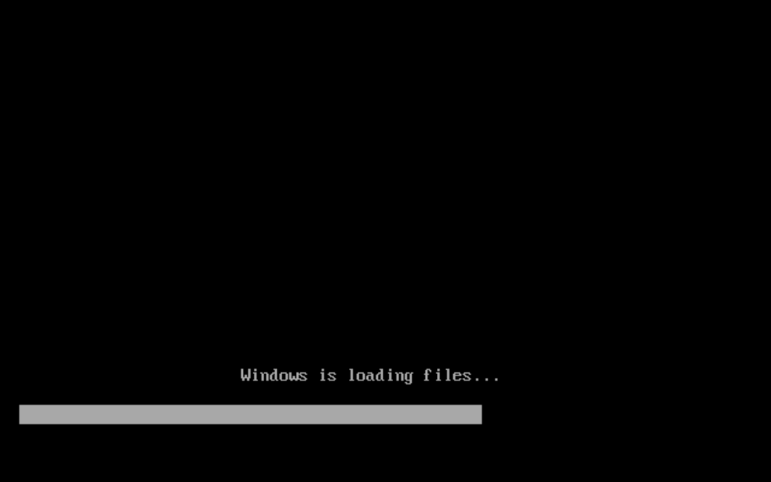

Figure 1 Windows is loading Files

Windows is starting and loading files from the DVD drive to the program memory. It takes time to finish the files loading steps.

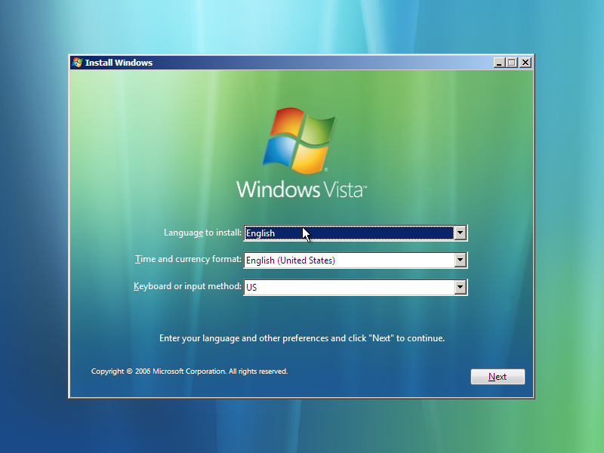

Figure 2 Setting Language

The language, time and current location as well as the keyboards inputs are selected in English setting.

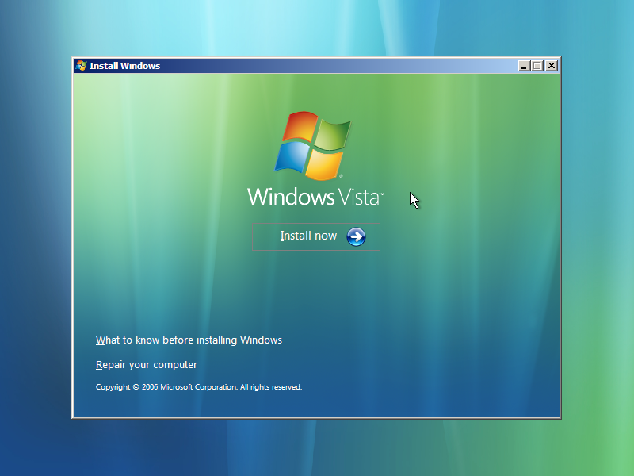

Figure 3 Install Fresh Version of Windows Vista

The Windows Vista welcome screen appears and press the “Install Now” button to continue further installation in progress.

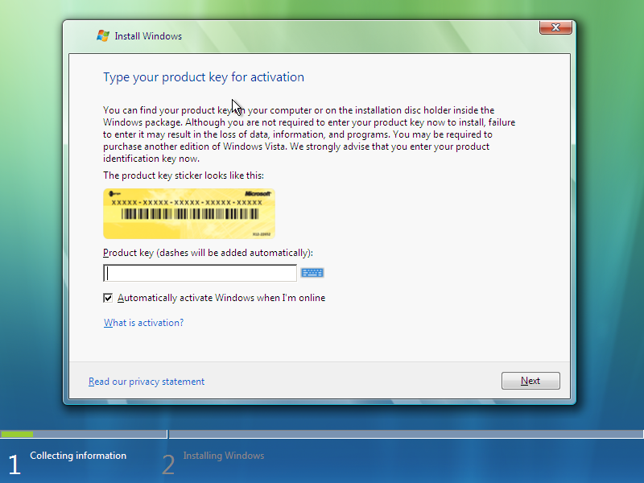

Figure 4 Type the product key for activation

The product key is typed in the key box for activation of Windows Vista installation automatically.

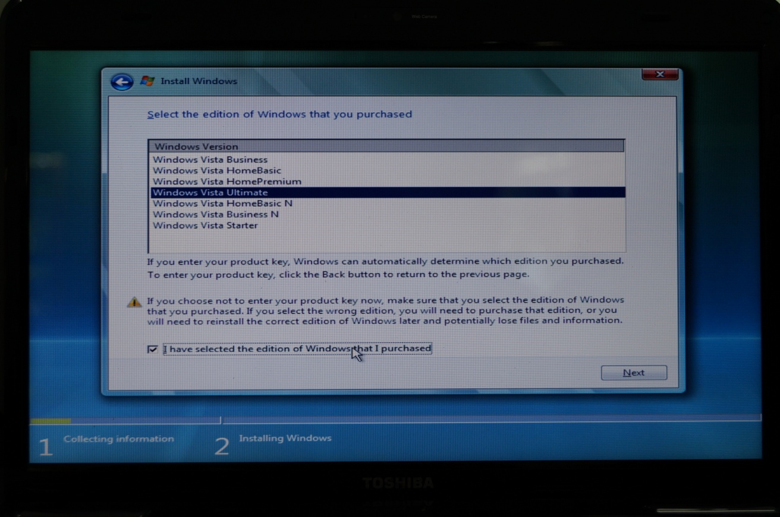

Figure 5 Select the Edition of Windows that purchased

The edition of the Windows Vista ULTIMATE is selected and click “NEXT” button to be continue.

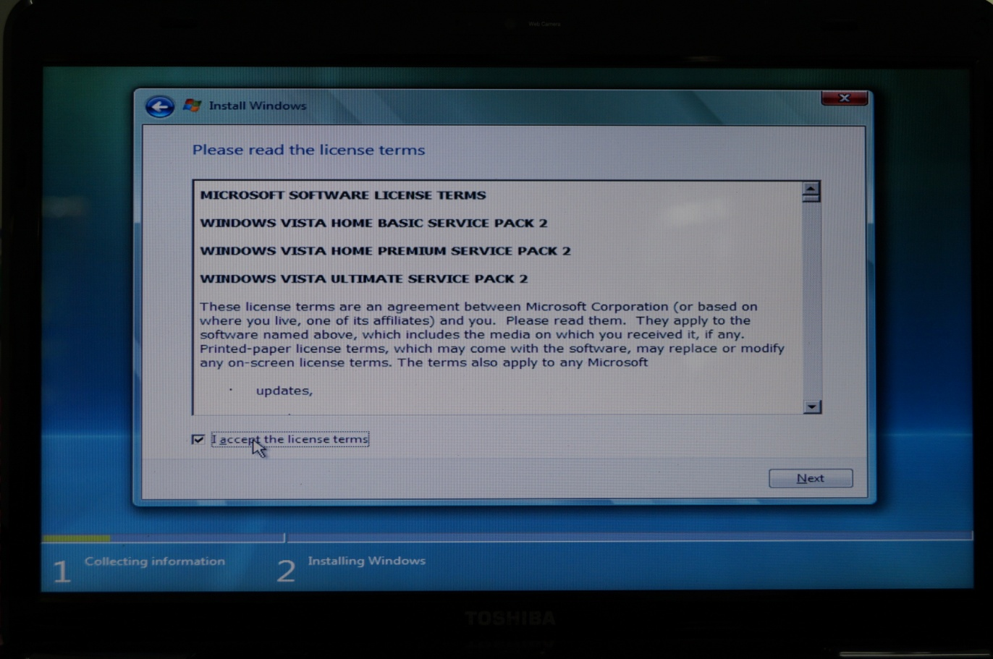

Figure 6 Read the license terms

The license terms are read and accept the license agreement and select the check box and click “Next”.

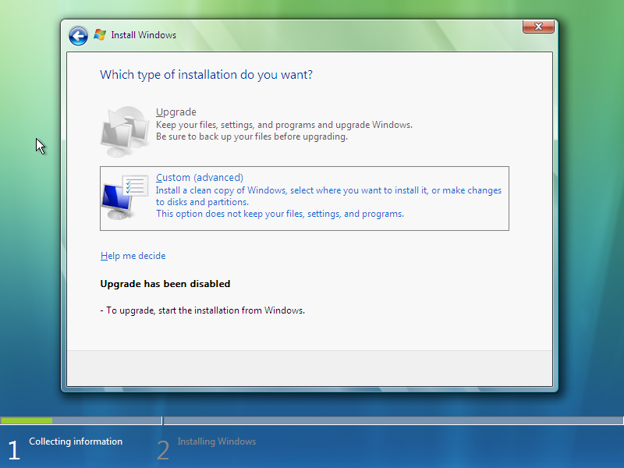

Figure 7 Select Installation Types

The type of installation is wanted to be selected as “Custom (advanced) to install a new version of Windows and changes are made to disks and partitions.

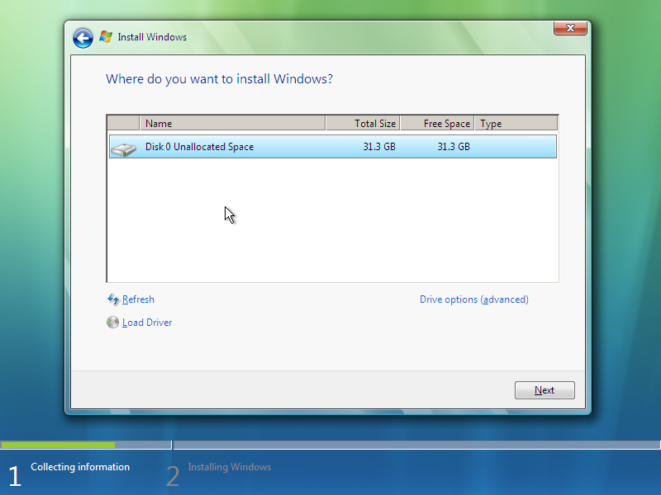

Figure 8 Primary Partition on the Hard disk

The Windows installs on the primary partition of the hard disk and select on the Disk Partition icon to continue fresh version of the Windows Vista operating system.

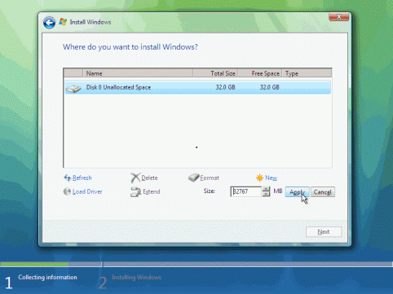

Figure 9 Disk Unallocated Space

The hard disk is now unallocated space. The storage space is selected as the user wants and press “Apply” button.

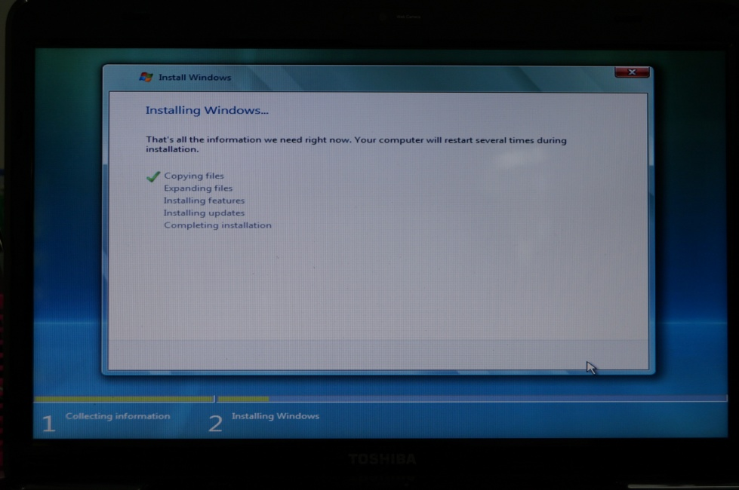

Figure 10 Installing Windows

Now, Windows is installing files in this step. All the information is available and after installation all steps, the computer will restart.

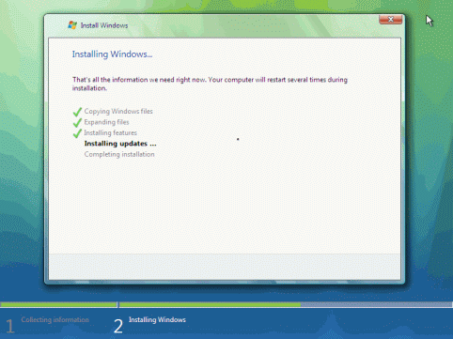

Figure 11 Installing Updates

The installing updates are now performing in this step. It takes a several minutes to complete installation.

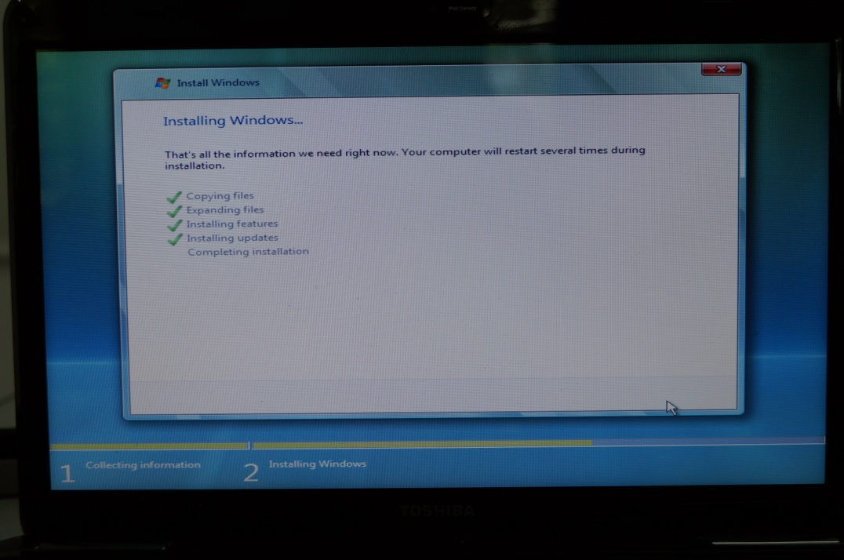

Figure 12 Complete Installation

In this step, installing Windows is processing the finalizing procedures to complete installation files.

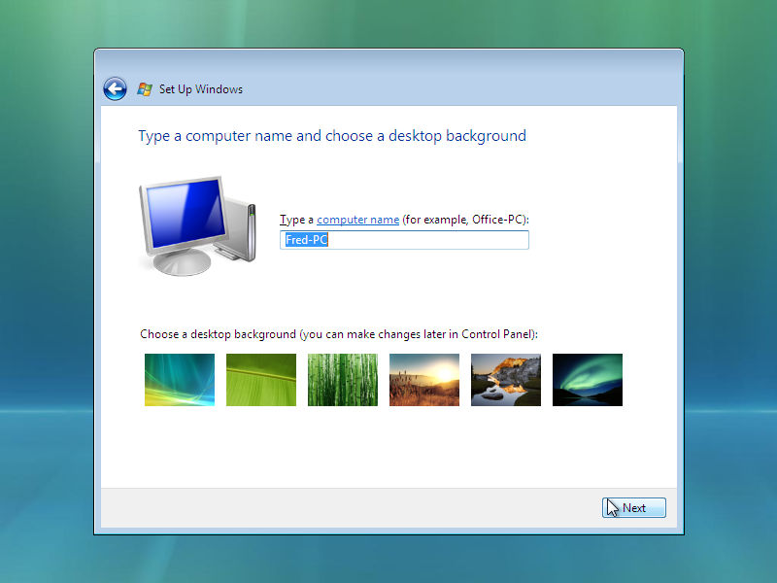

Figure 13 Set up Windows

In this stage, the computer name is typed and the desktop background is chosen as the user wants.

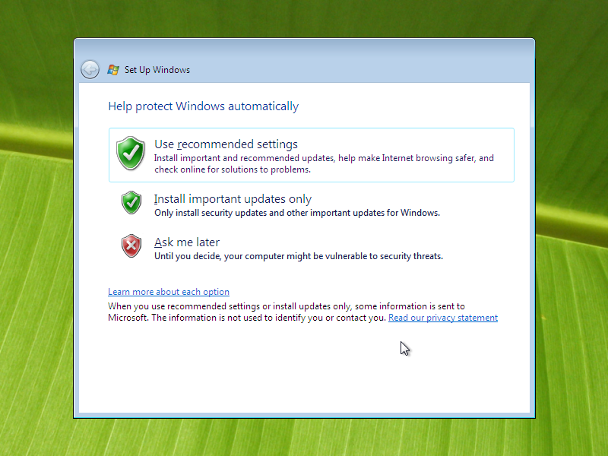

Figure 14 Windows Protection Setting

Windows is protected by user recommended settings for configuring and setting important updates, Internet browse makes safe and online is check for solution to problem.

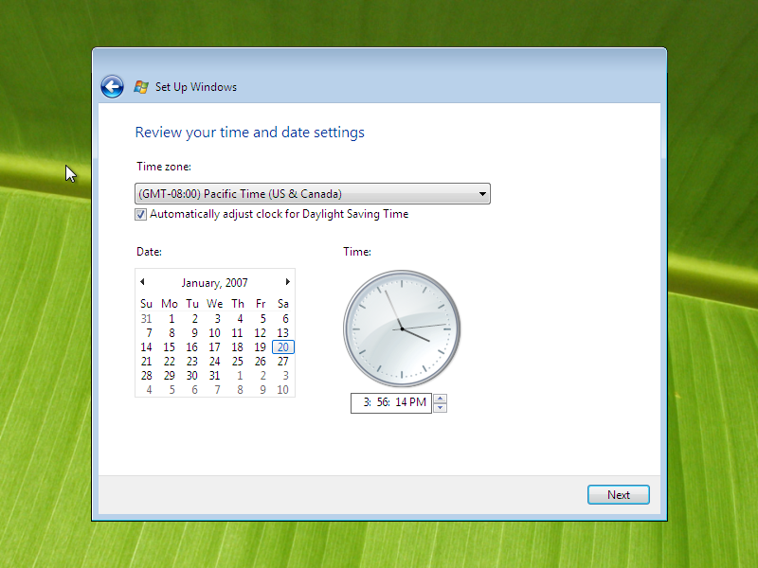

Figure 15 Time and Date Settings

The date and time setting is reviewed and select in the scroll down button.

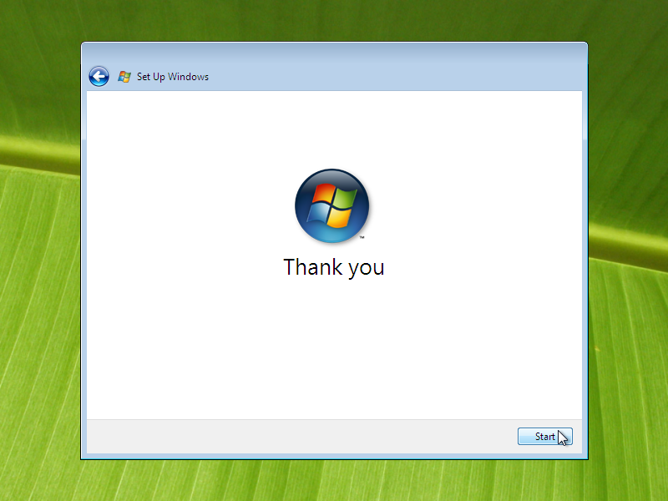

Figure 16 Finishing Setup

Set up and Configuration Windows is now finished.

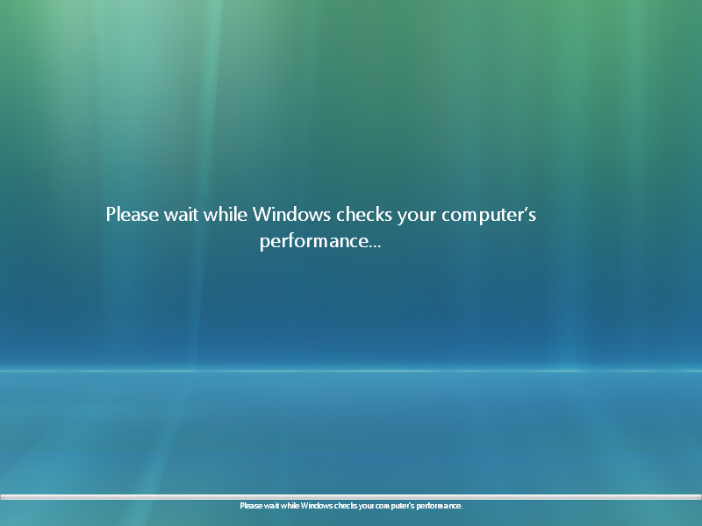

Figure 17 Windows check the Computer performance

Windows Vista checks the performance of the computer and wait for a while for best solutions.

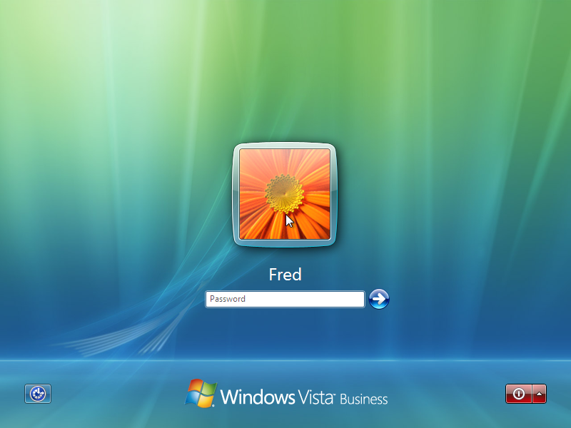

Figure 18 User Account and its Password

The administrator account setting request the password as the authentication process to access the computer system.

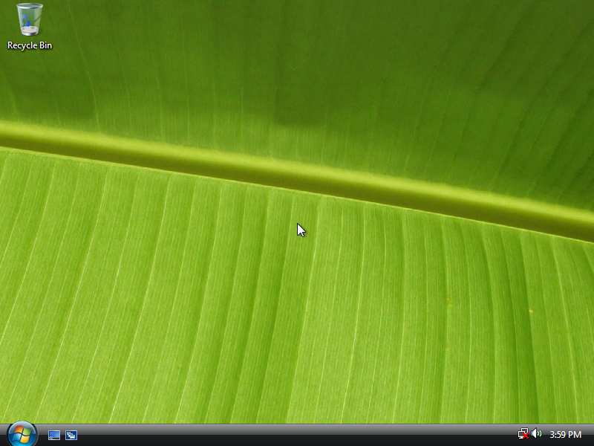

Figure 19 Windows Vista Desktop Background

The attractive and beautiful Windows Vista background screen can be seen at that time. On the desktop, there are some gadgets available..

## **1.2 Required Device Drivers Installation**

Windows operating system has no driver installation in one package. So, the device driver Pack Solution software needs to install. The key stages of installation are shown in below.

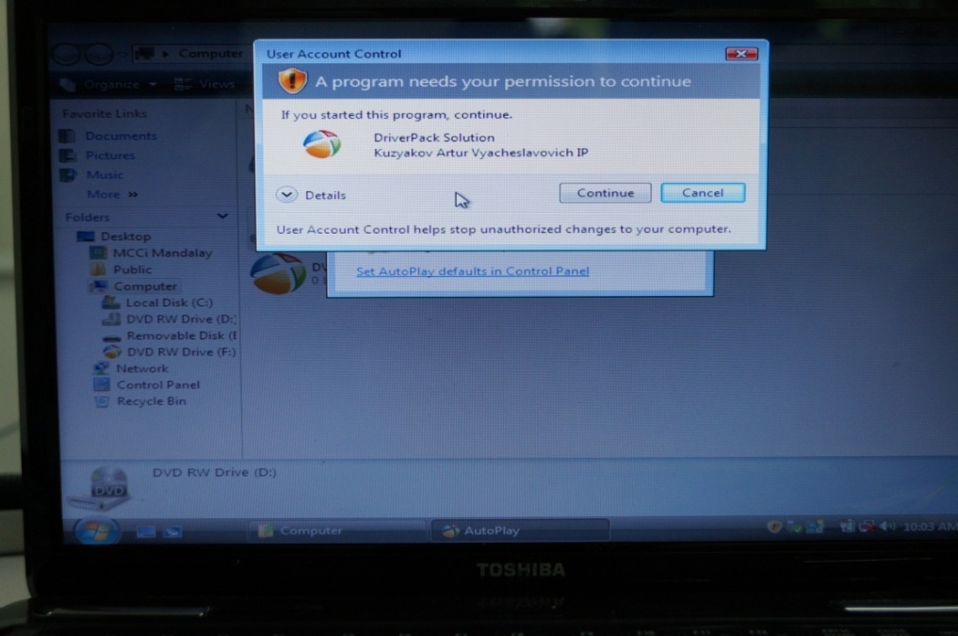

Figure 20 Preparing to install Driver Pack Solution

A device driver is software that is installed to Windows to communicate with hardware devices and operating system. Any hardware cannot work with computer correctly without device driver software. For instance, network devices, adapter cards inserted into the expansion slots cannot work correctly unless the driver software is.

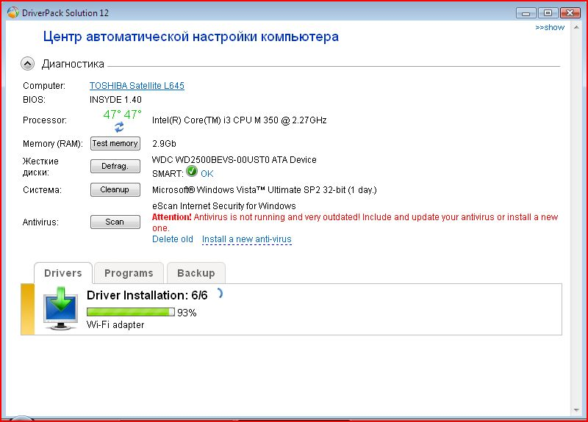

Figure 21 Driver Installation Progress

Windows Vista finds automatically new hardware and installs device driver software when “the New Hardware Wizard” in “Control Panel”. If there is an updated driver for a device is determined by Windows, the updated Hardware Wizard starts and installs the driver by following the “Next” instruction.

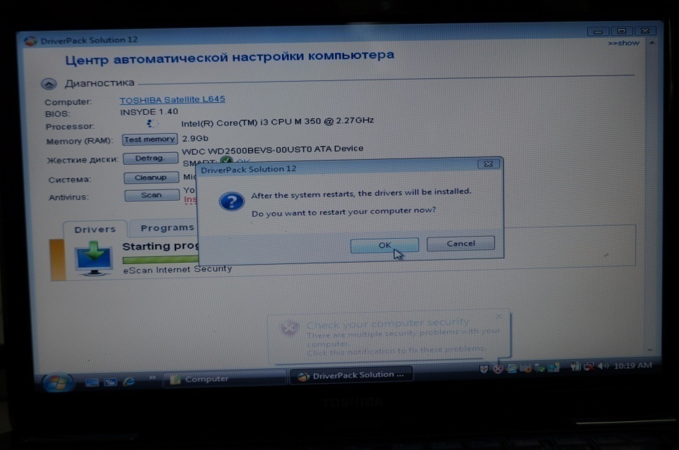

Figure 22 Completing Device Driver Installation and restarting the System

The device driver software is installing in progress for a several minutes, after completing installation, the system will restart for updated driver configuration.

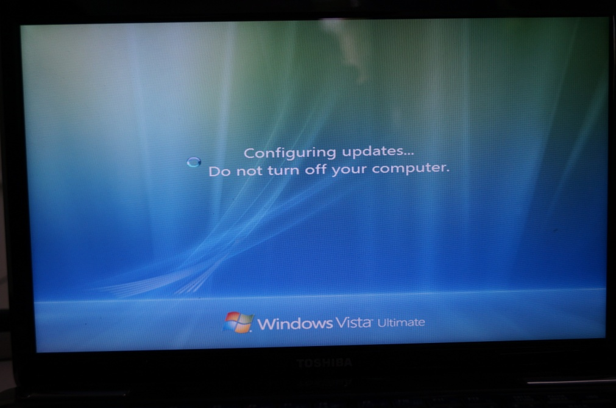

Figure 23 Configuring the Device Driver Updates

### **1.2.1 Location of Device Driver Software**

In this lab session, the driver installation isn’t connected by the Internet. The driver software is installed from the “Driver Pack Solution 12” CD. The hardware components of the computer system can be viewed in “Device Manager” program of the “Control Panel”.

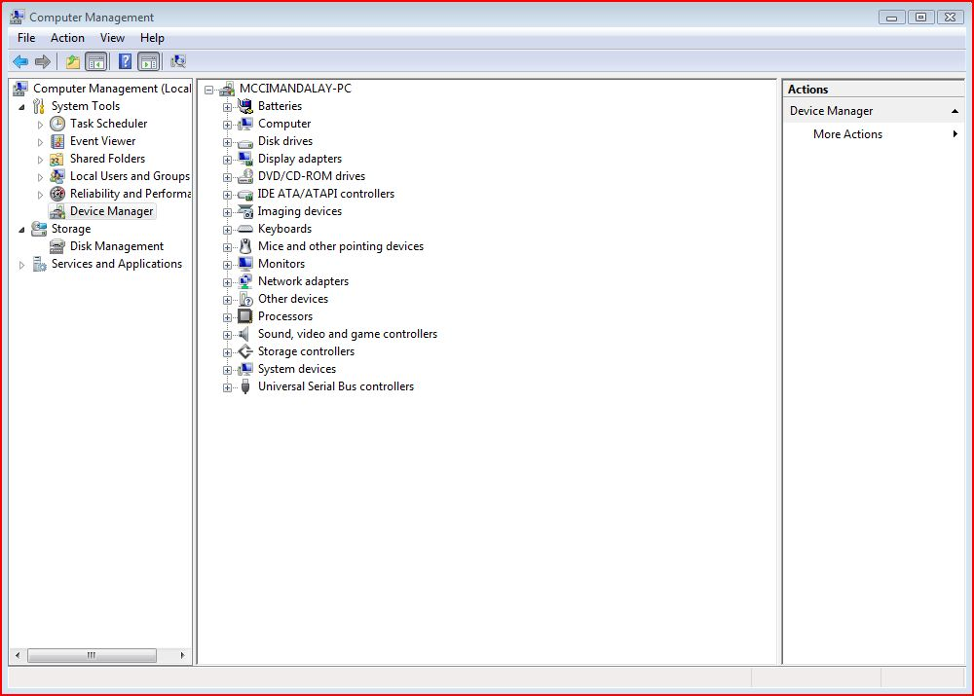

Figure 24 Device Manager Program

From the Control Panel, in the Computer Management program, select Device Manager, all the devices driver can be seen in this program.

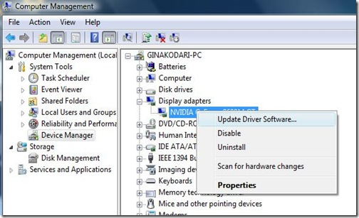

Figure 25 Update Driver Software

Under the Display adapter, NVIDIA GFORCE graphic display is right – clicked, pop – up menu appears, click on the Update Driver Software and install the device driver software.

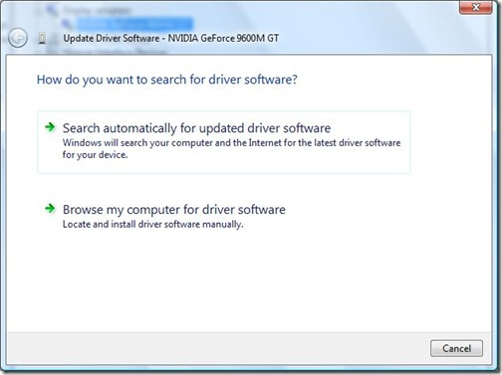

Figure 26 Search automatically for updated driver software

The updated driver software is searched automatically option is selected because Windows will search the computer and the Internet for the latest driver software for the devices.

.

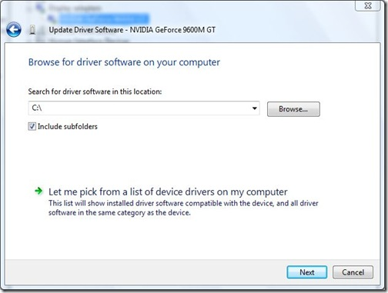

Figure 27 Browse for Driver Software on the Computer

The driver software is browsed on the computer in the location C:\.

**1.2.2 Unsolved Problems during Installation of Device Driver Software**

#### 1.2.2.1 Symptoms

The driver software cannot be installed in Windows Vista:

1. The driver program is file – based executable.
2. It is not designed for Windows Vista.

#### 1.2.2.2 Cause

Unsolved issues occur in the case of executable file – based program in the following conditions:

1. The driver software is not compatible with Windows Vista
2. The installation program is not supported for Windows Vista
3. The user right that is required to install the driver is an issue related to that user

#### 1.2.2.3 Resolution

1. The driver installation program is run in compatible mode
2. The driver installation program is run by administrative credentials
3. To install the .inf file and manually install the driver

## **1.3 Installation of Anti-Virus Software**

Information inside the computer has to be protected and the virus from various removable devices is prevented. The anti-virus software is a counter measure that against threats.

### **1.3.1 Microsoft Security Essential**

Security essential helps enhance the security and performance of the computer that is used in this assignment as the laboratory session.

MS security essential is used to guard against virus, spyware and other dangerous and harmful destructive program. It is free download anti – virus software, simple to install and simple to use.

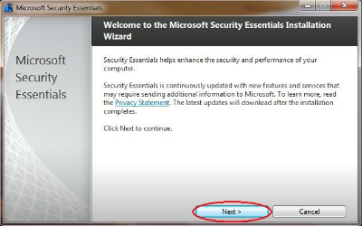

Figure 28 Microsoft Security Essential Installation Wizard

Security Essentials helps enhance the security and performance of the computer and click “Next” to continue installation.

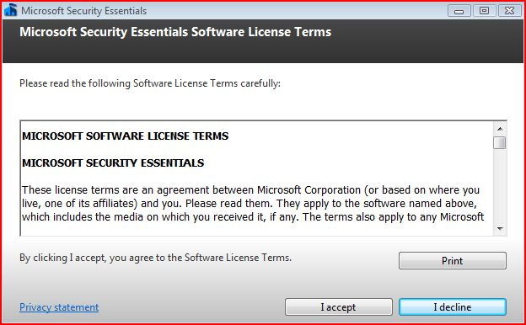

Figure 29 MS Security Essentials Software License Terms

The following software license terms are read carefully and click “I accept” button for license agreement.

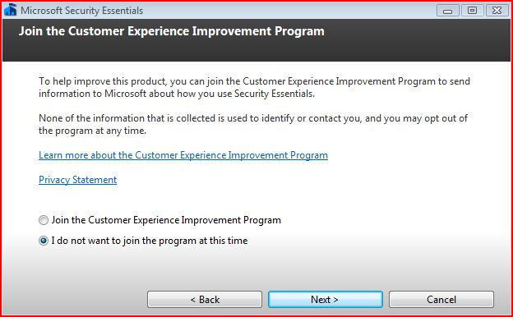\

Figure 30 Join the Customer Experience Improvement Program

In the next window you’ll see on 'Join the Customer Experience Improvement Program', select the radio button **I do not want to join the program at this time**, click **Next**.

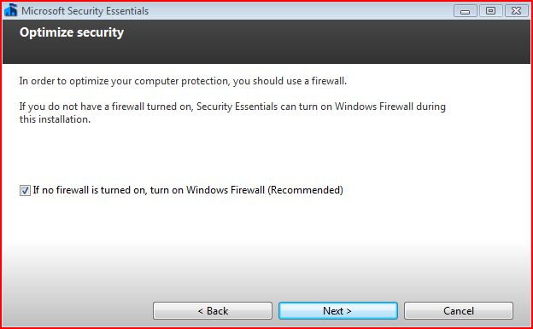

Figure 31 Optimize Security Essentials

In order to optimize the computer protection, a firewall should be used. If the firewall is not turned on, Security Essential can turn on Windows Firewall during this installation.

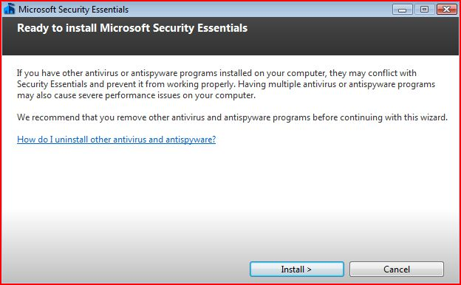

Figure 32 Ready to install the Program Installation Wizard

If the computer has other antivirus or antispyware programs installed, they may conflict with Security Essentials and prevent it from working properly.

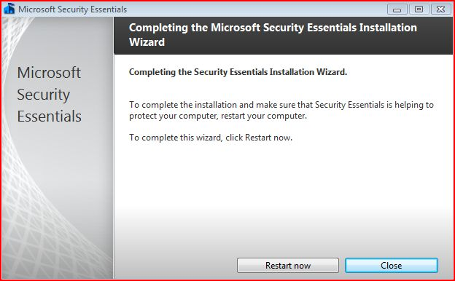

Figure 33 Complete Installation Wizard

To complete the installation and make sure that Security Essentials is helping to protect the computer and restart the computer.

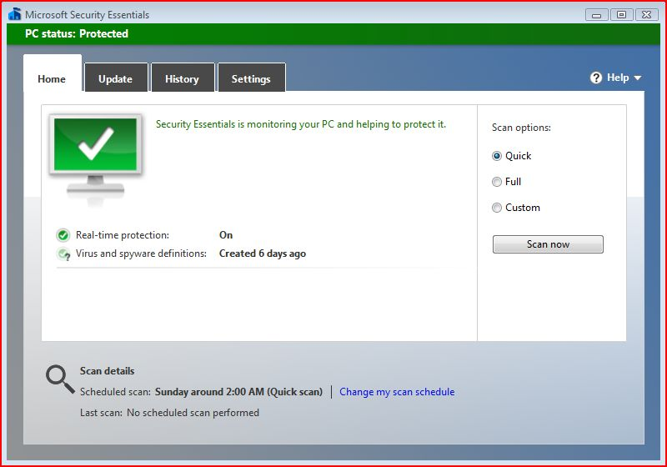

Figure 34 Protected PC

If the computer is infected, the whole scan is performed under the Home tab, select the Quick Scan button for monitoring the PC and protecting it.

## **1.4 Installation of Microsoft Office software**

The Microsoft Office 2010 is installed in the assignment report. The key stage of installation is presented as follows:

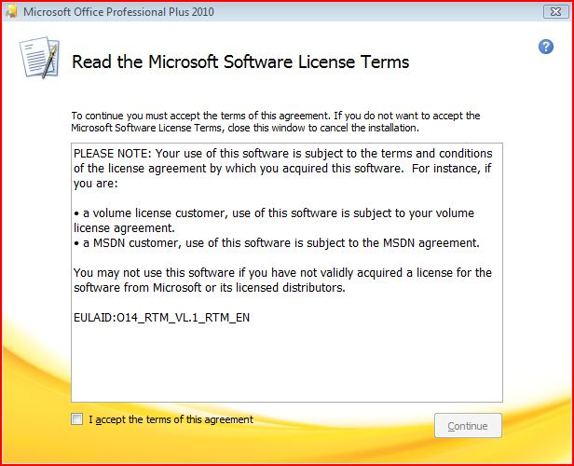

Figure 35 License Agreement Terms and Accept to continue installing

To continue installation, the terms of the License agreement is accepted. Unless, close the window and cancel installation.

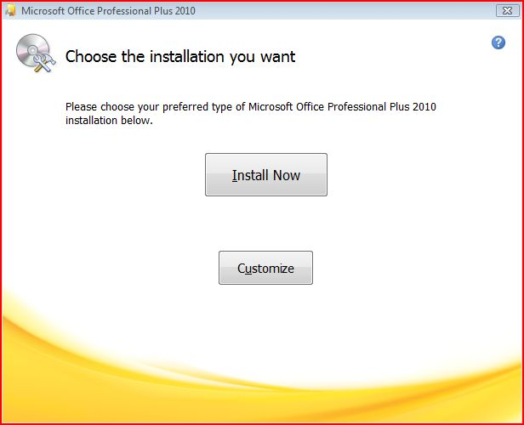

Figure 36 Select the Installation Types

The preferred type of Microsoft Office Professional Plus 2010 is chosen for further installation.

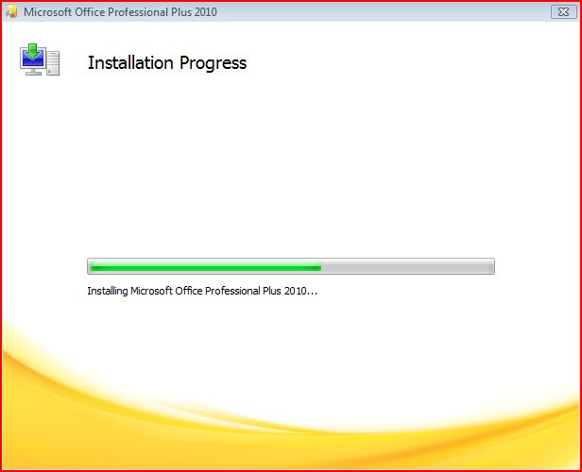

Figure 37 Installing Microsoft Office 2010 in progress

Installation is in progress and it takes for a few minutes and users wait patiently to complete configuration.

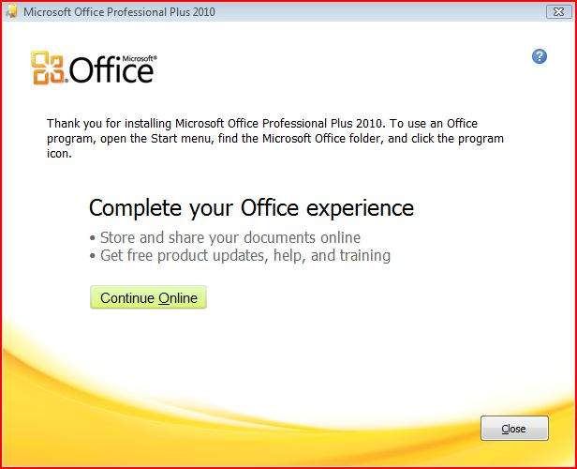

Figure 38 Complete installation and ready to use

The installation wizard finishes and closes the windows. The application program is open in the “All Program” under “Start” button.

## **1.5 Installation of Microsoft Free Tune Up Utility**

The utility program is released by Microsoft for maintaining and customizing all Microsoft’s Windows and application software, it is free and downloaded on the Internet. The Tune up utility software is installed to the Windows Vista operating system. The step by step installation is provided in next session.

### **1.5.1 Key Stages of Installation**

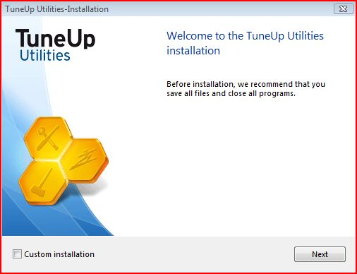

Figure 39 Tune up Utility Installation Wizard

TuneUp utilities installation wizard screen comes out and click “Next”.

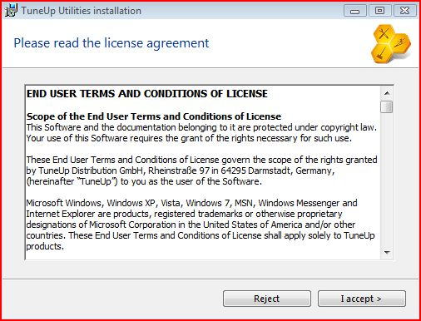

Figure 40 Accept End User License Agreement

Read the license agreement and click “I accept”.

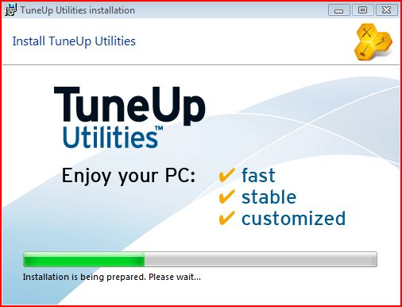

Figure 41 Installing Utilities with fast, stable and customized for computer performance

Installation is being prepared and progress bar indicates the status of installation.

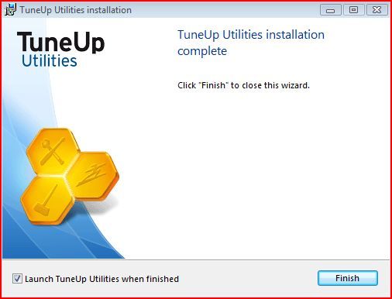

Figure 42 Complete Installation of Utilities

The windows shows the installation is complete and click “check box” to launch TuneUp utilities when finished.

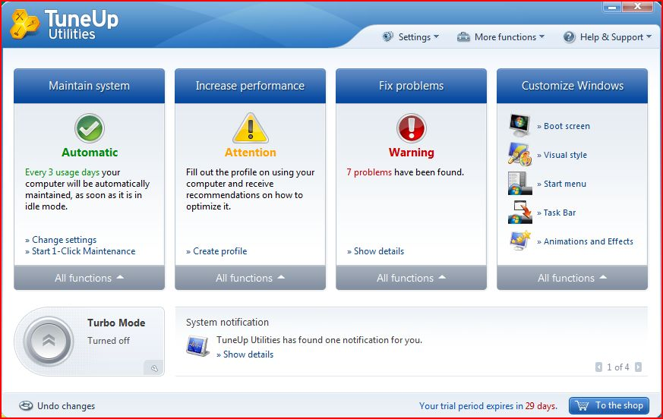

Figure 43 Running tune up Utilities for Performance Speed up

Perform TuneUp Utilities for customizing and maintaining the computer to speed up the processing power.

## **2.1 Installation of Red Hat Linux**

Linux system is based on the UNIX system, it is open source and Kernel that does key resources management such as processor scheduling and decide which processor to run and switching between processes.

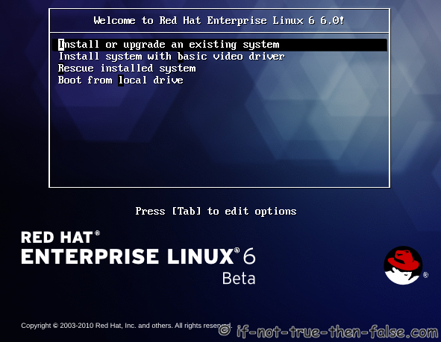

Figure 44 Red Hat Linux Operating System

To install the new version of the RED HAT Enterprise Linux version 6, select the uppermost option then continue installation.

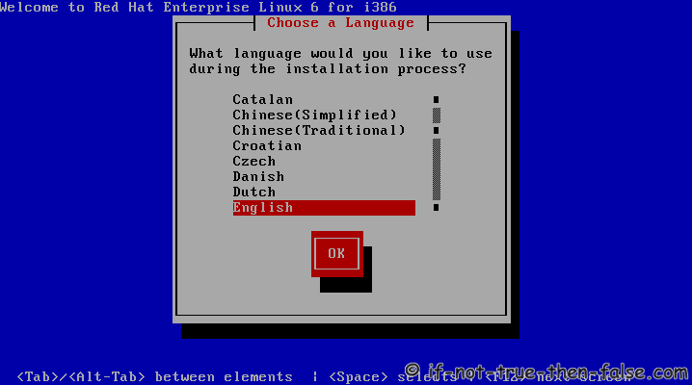

Figure 45 Language Setting

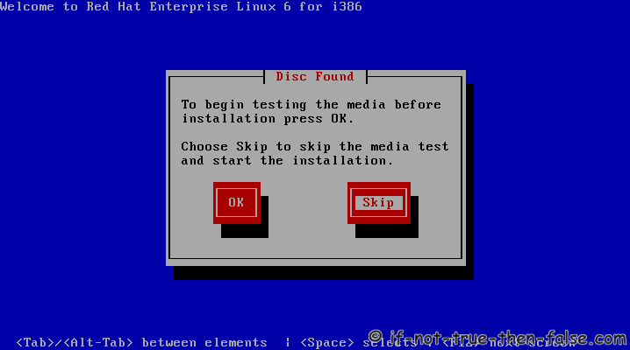

Figure 46 Testing Hard disk before installation

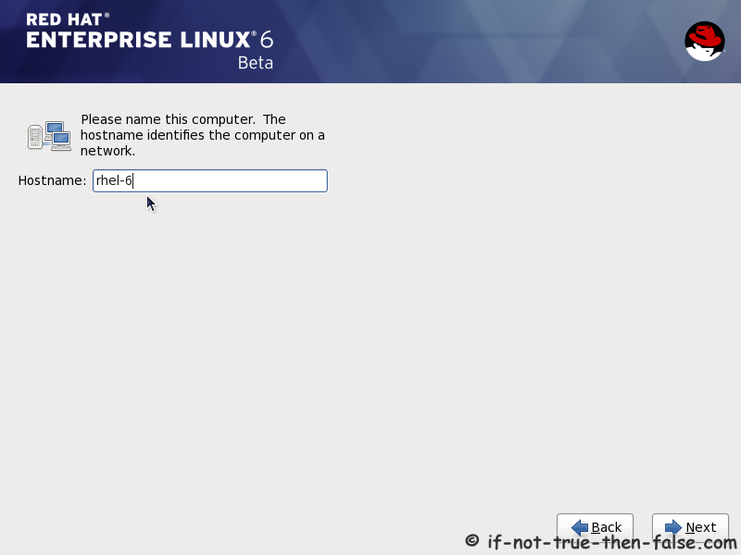

Figure 47 Red Hat Enterprise Linux 6

Type the computer name. The host name identifies the computer on a network.

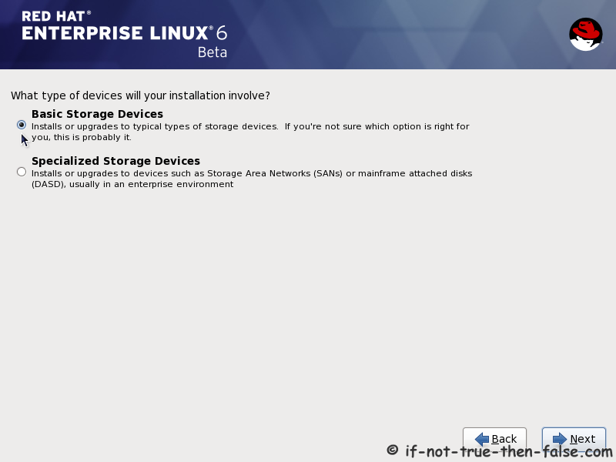

Figure 48 Select the type of Installation Device

For simplest installation, select “Basic Storage Devices” in this mode, Red Hat Linux installs and upgrades to typical types of storage devices.

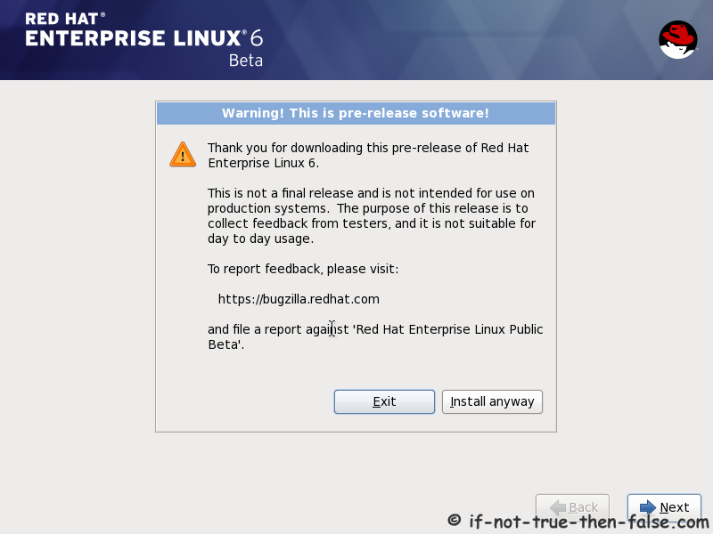

Figure 49 Download Software Release Notes

Click “Install Anyway” button and then click “Next” to go on installation.

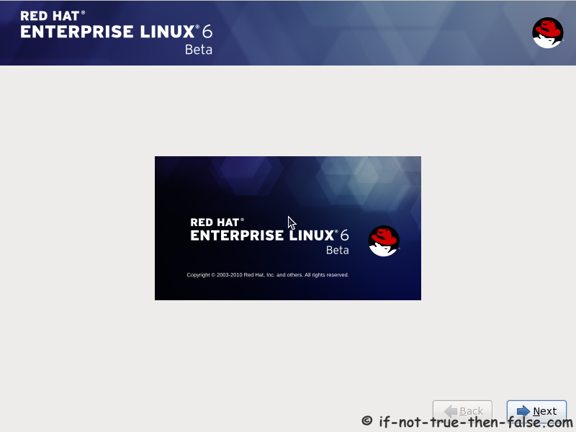

Figure 50 Welcome Screen of Red Hat Enterprise Linux 6 Beta Version

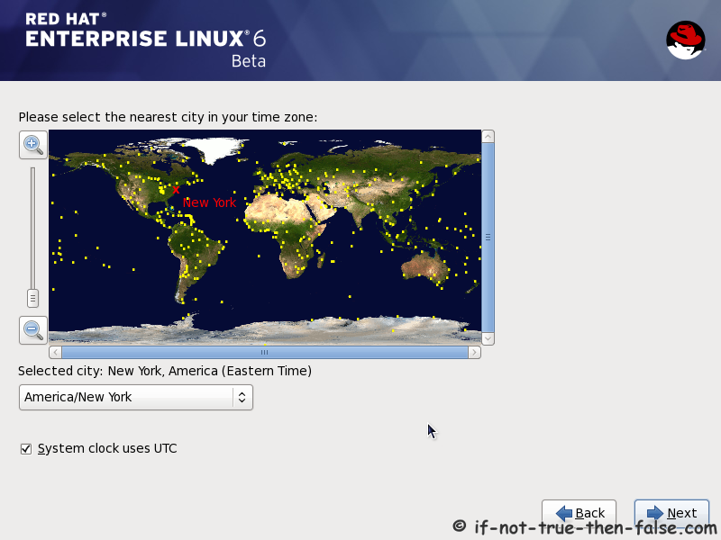

Figure 51 Locate or Point out the a Place where the user lives

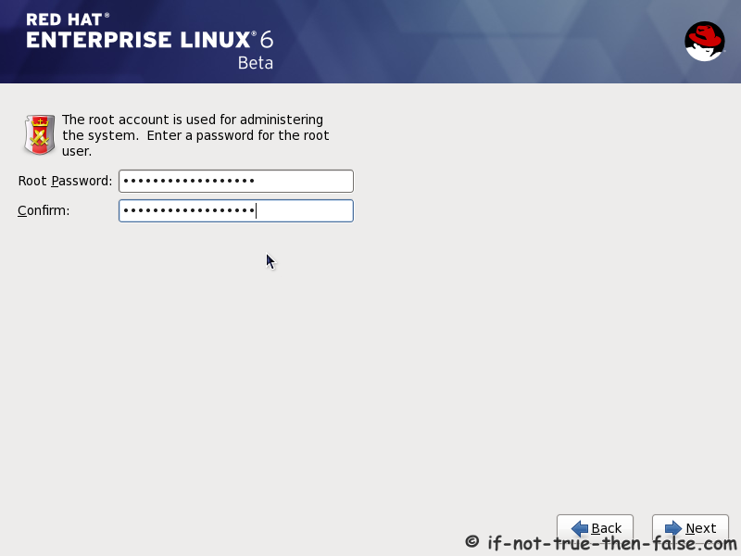

Figure 52 Type Root Password and Confirmation

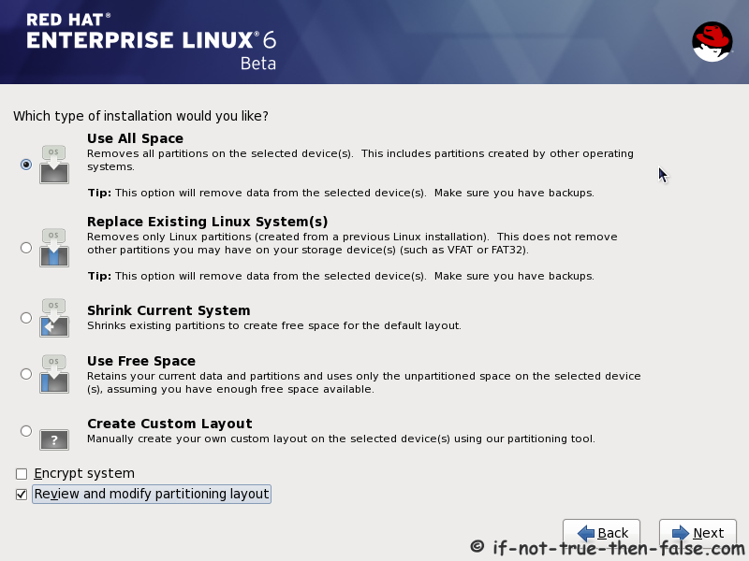

Figure 53 Select the type of Installation

Click on the “Use All Space” button to remove all partitions on the selected devices. This includes partitions created by other operating.

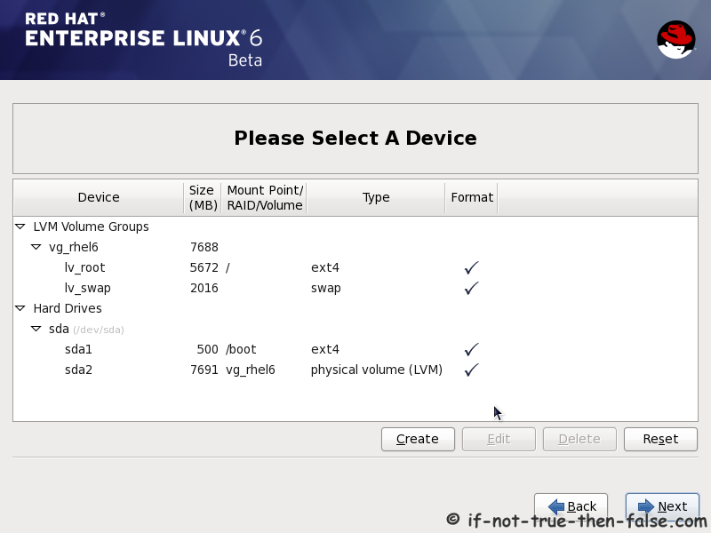

Figure 54 Partitioning Disk Druid on the All Space of Hard Disk

The partition tool used by installation program is Disk Druid that can handle the partition requirements for a typical installation.

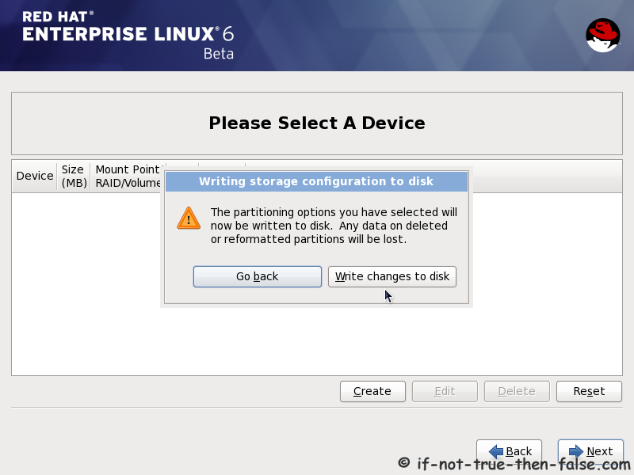

Figure 55 Create a New Partition

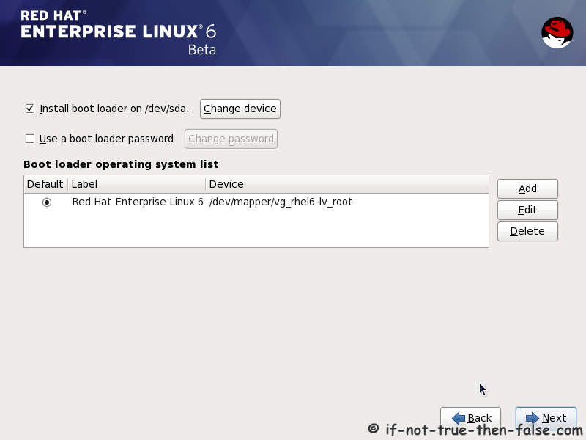

Figure 56 Install Boot Loader

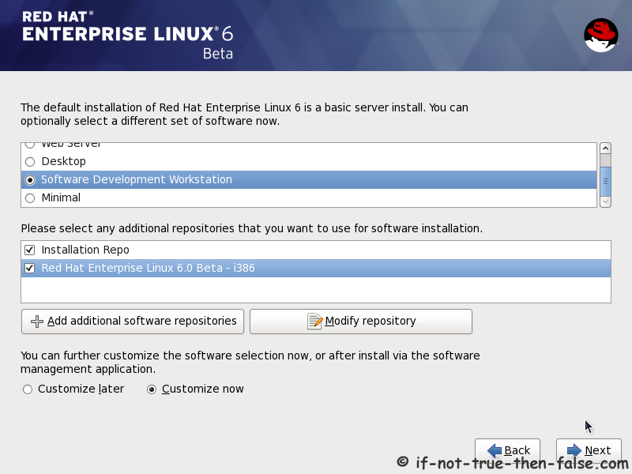

Figure 57 Software Development Workstations

The default installation of Red Hat Enterprise Linux 6 is a basic server install. A different set of software can optionally be selected.

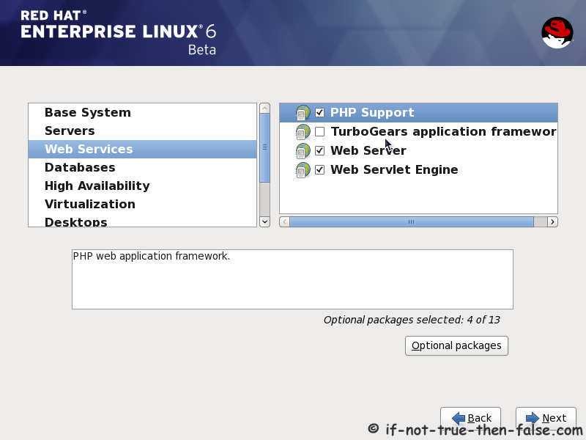

Figure 58 Packet Group Details

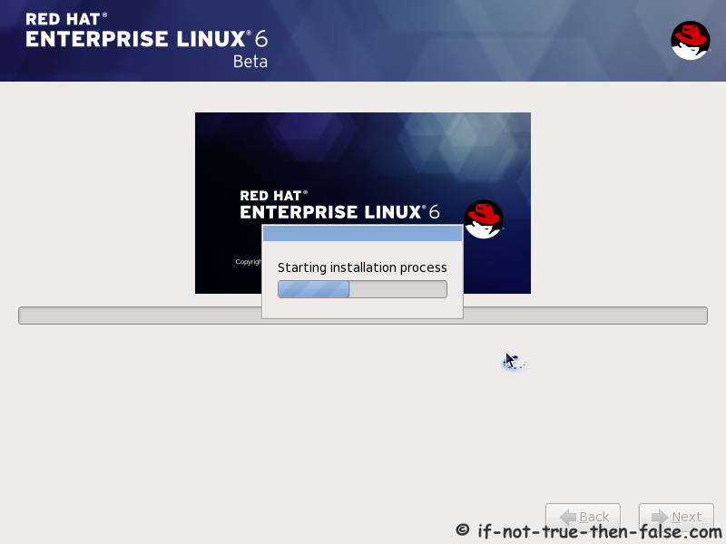

Figure 59 Starting Installation Process

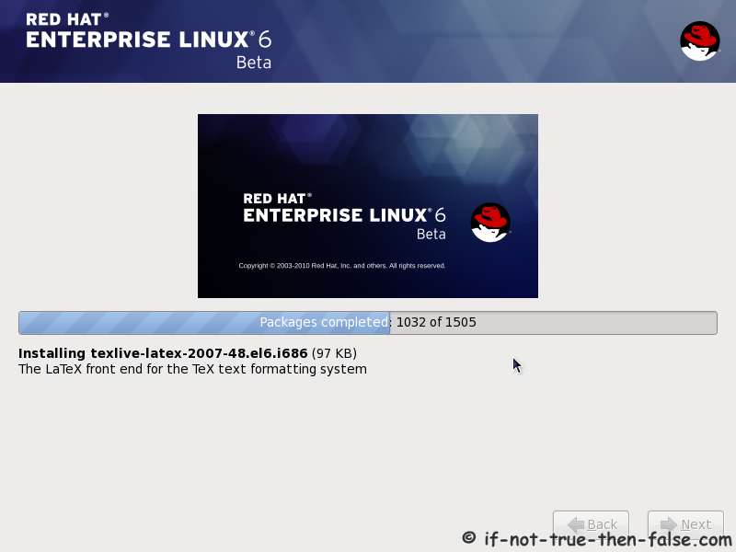

Figure 60 Packet Installation completed is still in Progress

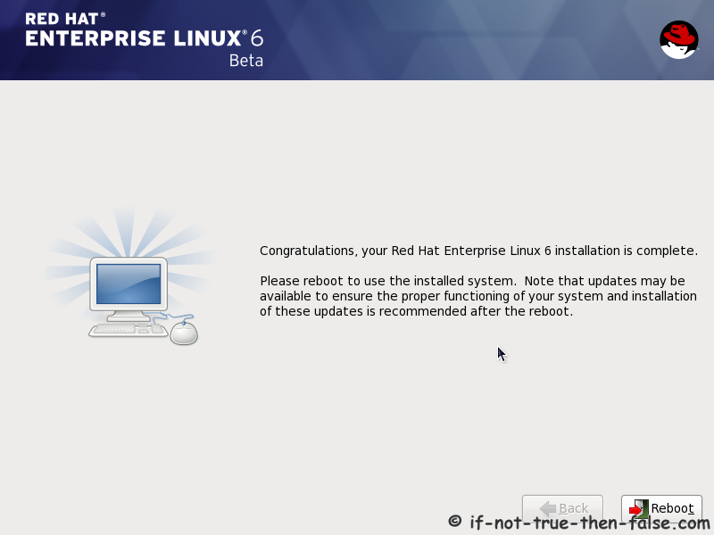

Figure 61 Finish Basic Installation and reboot the System



Figure 62 Initializing and updating the System

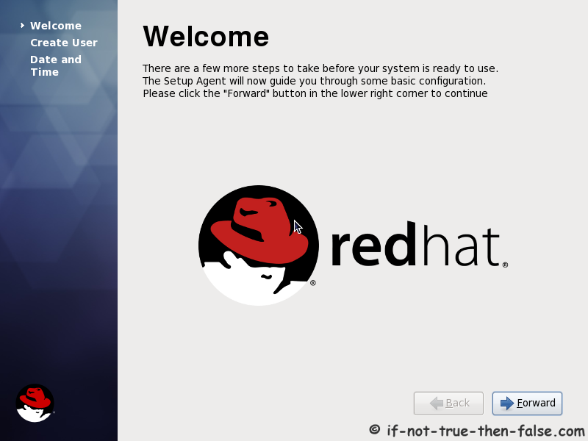

Figure 63 Forwarding more steps form this welcome Red Hat Linux Window

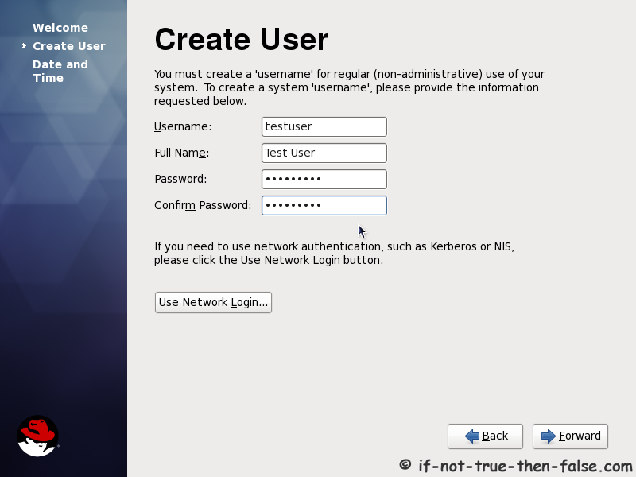

Figure 64 Create a User Account

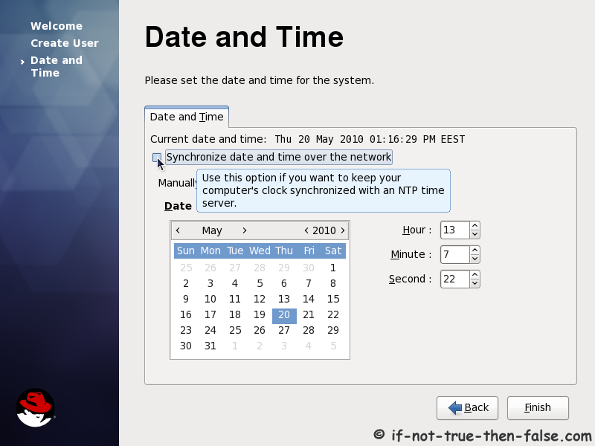

Figure 65 Date and Time Settings

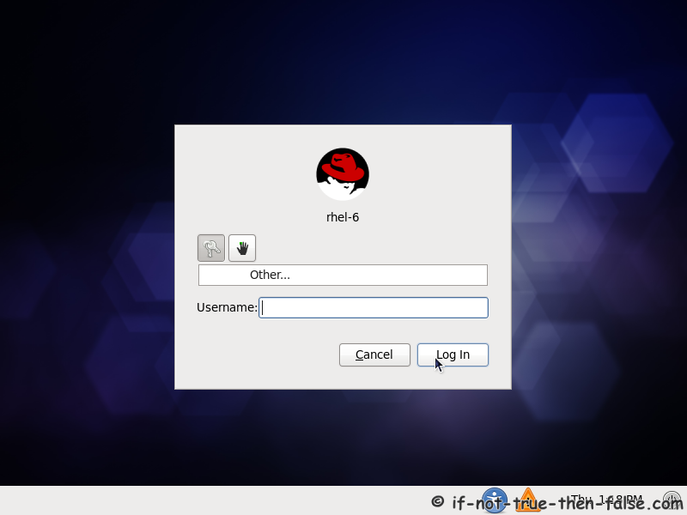

Figure 66 Type the predefined User Name

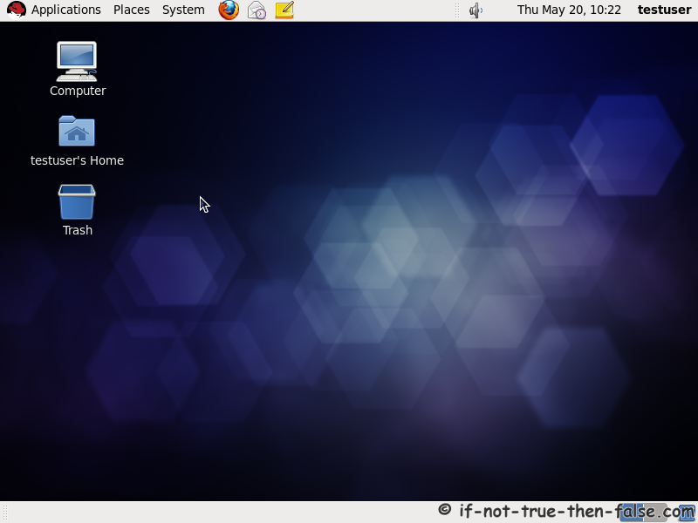

Figure 67 Red Hat Linux Desktop Background

## **2.2 System Testing**

1. Segmentation Fault is that program accessed a memory location that was not assigned to it. That may be due to a bug in one of the software programs that is installed or faulty hardware.
2. Media check is performed on the installation CD-ROM. The red hat Linux installation program has the ability to test the integrity of the installation media.
3. Red hat recommends that all installation media before starting the installation process and before reporting any installation related bugs.

### **2.2.1 Unsolved Problems**

1. Problems with booting into the graphic installation
2. No device found to install Red Hat Enterprise Linux Enterprise Linux Message Error
3. Trouble with partition table
4. Python errors
5. User login password error

## **3.1 Faulty PC**

When a computer system fails, there are generally two possible causes: hardware or software. It begins with failures and symptons associated with

1. PSU (Power Supply Unit)
2. System boards
3. RAM
4. Microprocessor
5. ROM
6. KeyBoard
7. Mouse
8. Video
9. Hard-Disk Drive
10. Network Card

### **3.1.1 Power Supply Problem & Fault Remedy**

The diagnosis of the power supply problems can be seen as no indicator LED displays such as power LED, speaker LED, HDD LED and reset LED. The display screen is black. The power cable of the PSU is tested by multi-meter. If the error finds in the unit, exchange the new one.

### **3.1.2 System Boards Problems & Fault Remedy**

There are many electronic devices on the system board; the first bootable program is stored in the ROM chip, the heart or brain of the microprocessor, the peripheral I/O ports, expansion slots, RAM modules and other controllers. If one of the devices fails, the system cannot boot. The system board said to be corrupted. The new board is replaced instead of old motherboard.

## **3.1.3RAM Problems & Fault Remedy**

RAM problems arise in two ways; soft error – the system is restarted and hard error – exchange the new RAM.

### **3.1.4 Microprocessors Problems & Fault Remedy**

Microprocessors problems causes due to overheating and some pins are short. Due to microprocessor fault, firstly, the cooling system is removed, the lever is lifted and then the processor IC is replaced with a new one compatible with the number of pin, operating speed of the old microprocessor.

### **3.1.5 ROM Problems & Fault Remedy**

In the ROM, the manufacture’s BIOS program is permanently stored. The program runs as soon as the power is received by the system. So, as the power button is pressed, there no any detection process is done, it is ensure that the ROM chip is fail. The chip can be replaced if it comes with sockets. If not, the system board is exchanged.

### **3.1.6 Keyboard Problems & Fault Remedy**

Keyboard may be fail due to its switch damaged or driver of the keyboard is corrupted. As the keyboards are abundant and inexpensive and it is a removable device. So, it is very easy to replace with a new keyboard.

### **3.1.7 Mouse Problems & Fault Remedy**

Mice problems occurs dust in most truck ball types. This disrupts the operation of the mouse. But the optical mouse sometimes hinter the operation of the device without dust.

.

### **3.1.8 Video Display Problems & Fault Remedy**

Graphic cards are built – in motherboard; the display screen is black after booting the computer system. The whole underlying motherboard is needed to change. Some graphic cards come with expansion slots on the mother board. This type of VGA is easy to replace.

### **3.1.9 Hard – Disk Drive Problems & Fault Remedy**

Hard – disk is a data storage device, it also stores operating system. Data must be handled permanently in the backing storage device. Due to bad sectors on the storage media, the hard disk is corrupted. The operating system is rebooted again and formatted the whole disk, the disk may be recovered. If the system does not operate in a normal mode, the hardware errors occur. The hard disk is exchanged with a new device.

### **3.1.10 Network Cards Problems & Fault Remedy**

Computer systems are networked for resource sharing and internet access. The communication links – such as – data cable, ports, and cable connection must be checked for proper configuration. The network interface card (NIC) is an adapter card inserted into the expansion slots or on board. The device driver program may be corrupted; the network does not work well. The driver software is updated and reinstalled again. The network operation becomes fair.